Core Java Assignment-1

1)Find out if the given number is an Armstrong number.

Logic-if 153 is the Supplied Value then 1^3+5^3+3^3=1+125+27=153.

This is the same as supplied value hence it is an Armstrong number.

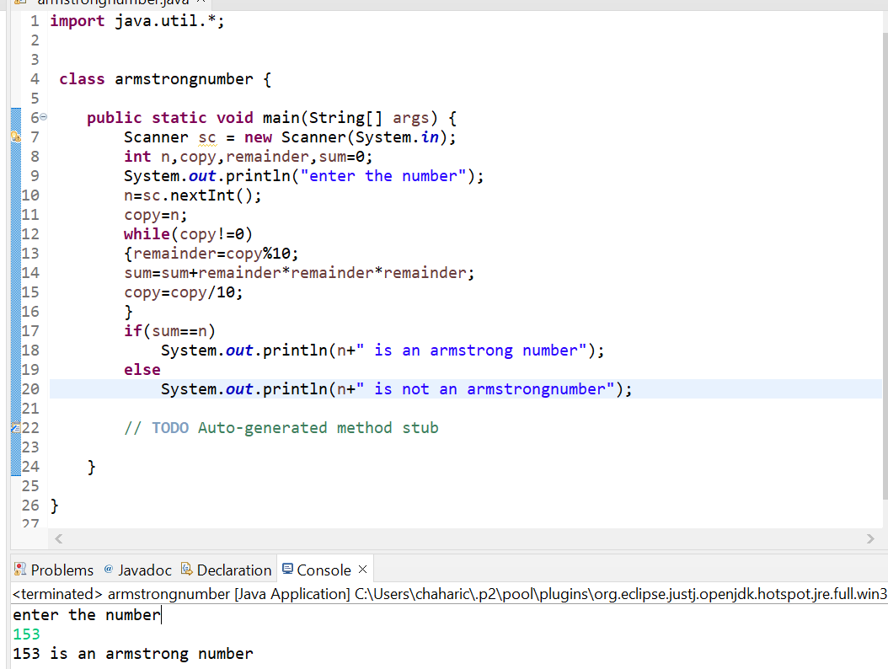

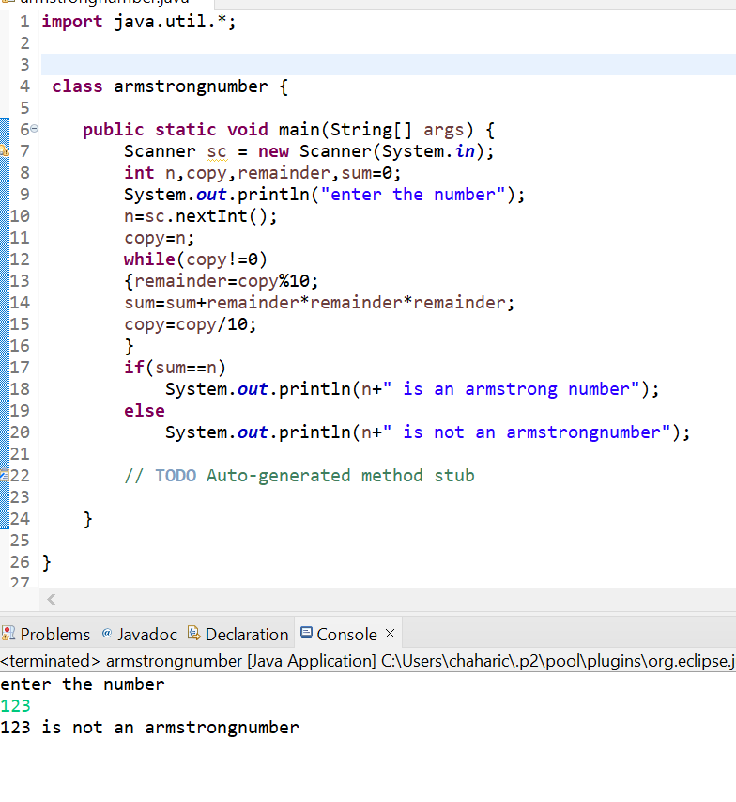

2.Find out all the Armstrong Numbers falling in the range of 100-999.

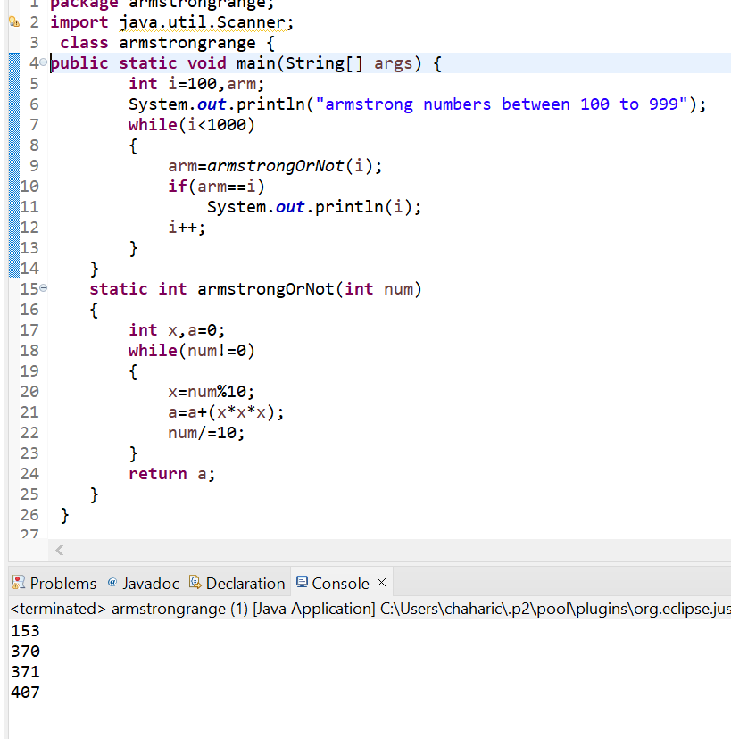

3.Find out the simple as well as the compound interest of supplied value.

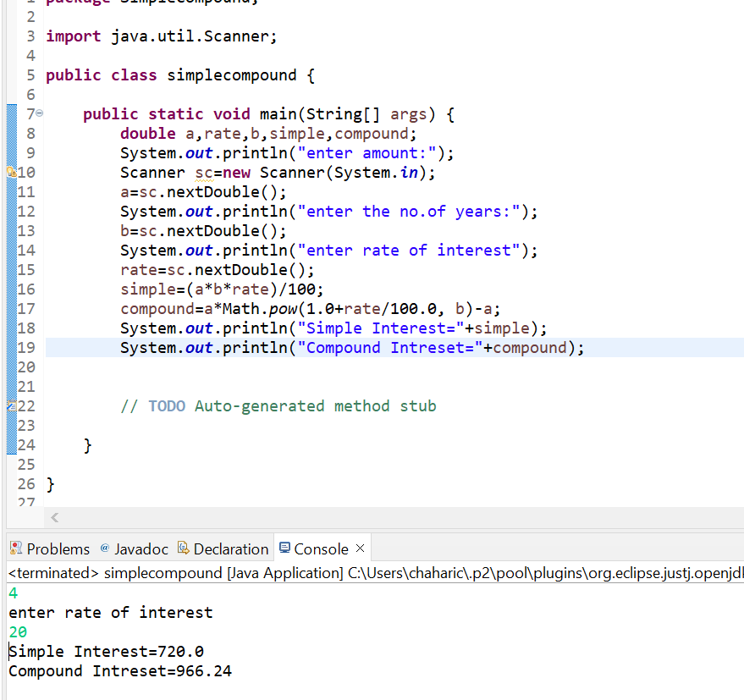

4.Supply marks of three subjects and declare the result, result declaration is based on below conditions.

Condition 1: All Subjects marks is greater than 60 is passed.

Condition 2: Any two subjects marks are greater than 60 is promoted.

Condition 3: Any one Subject mark is greater than 60 or all subjects marks less than 60 is failed.

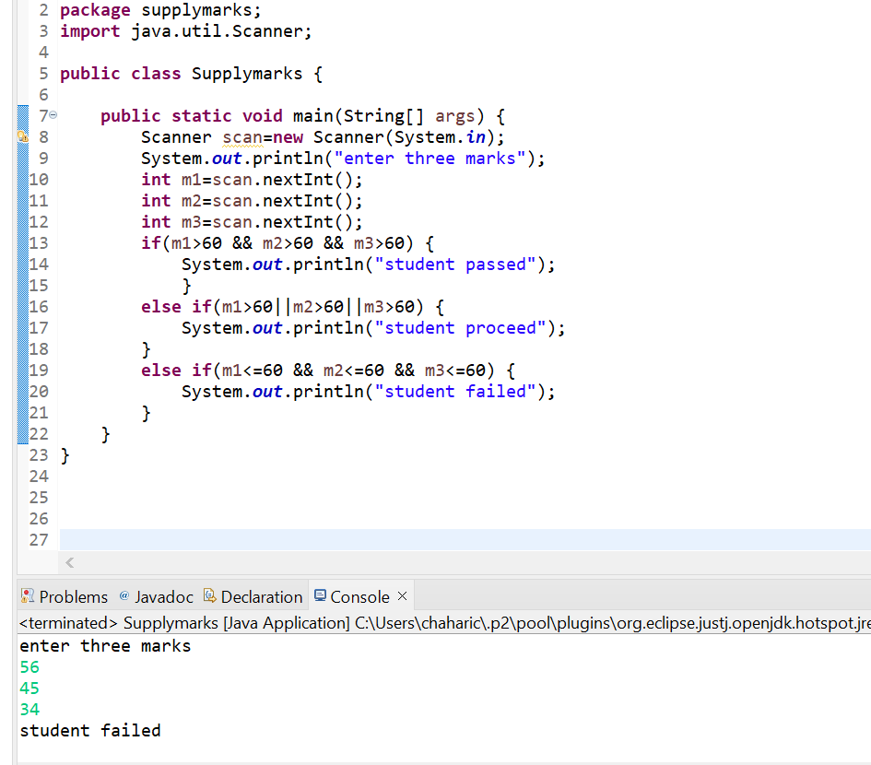

5) There is an array which is of the size 15, which may or may not be sorted. you should write a program to accept a number and search if it in contained in the array.

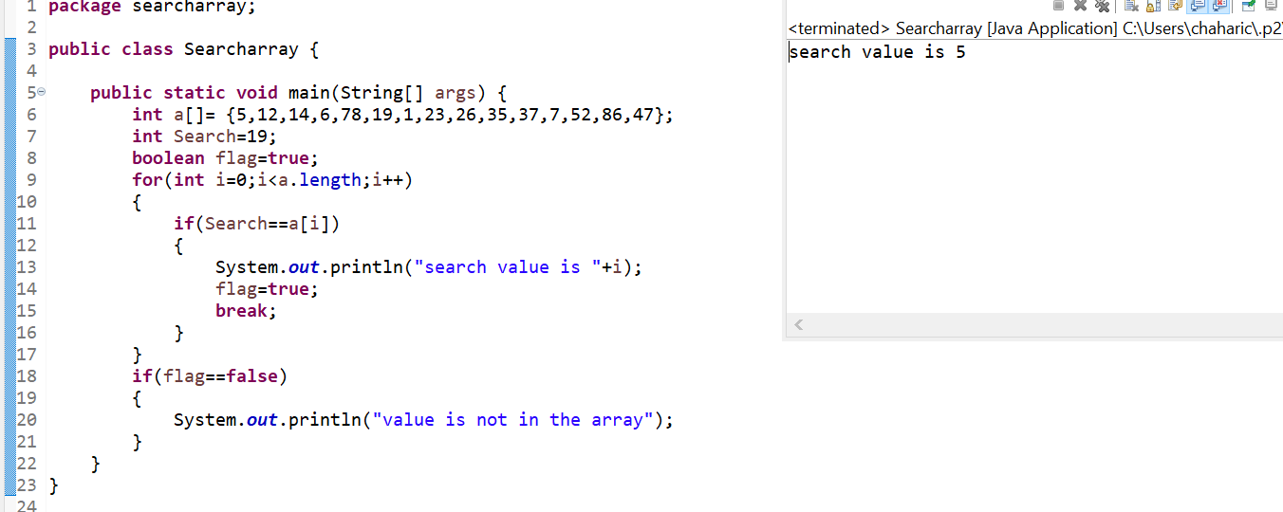

6) using the above array write a method apply sorting using Bubble sort.

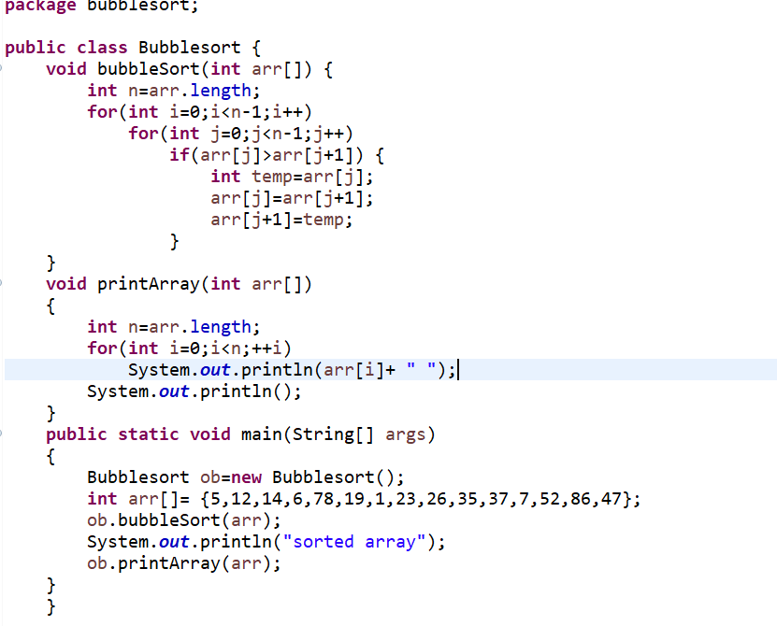

Output:

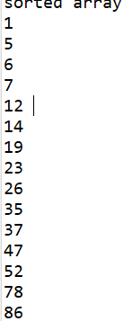

7)Accept the marks of three students for the subject A,B,C. Find the total scored and the average in all the subjects. Also find the Total and average scored by students in each respective subject.

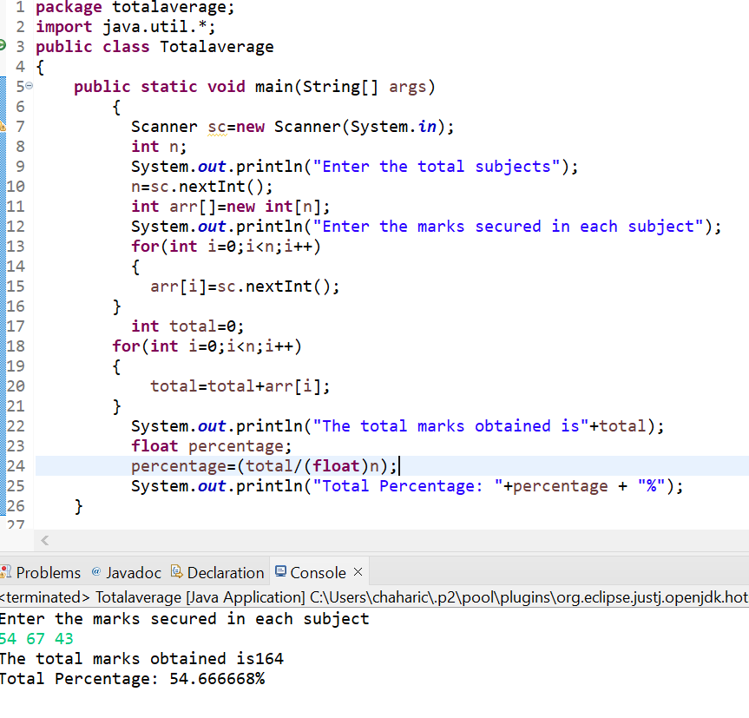

8)Calculate the income tax of the following table.

